Γλωσσάρι Αγγλικών ΣΤ Δημοτικού

A
/ əkaʊnt /
account
noun (countable)
- a description a story
περιγραφή, εξιστόρηση
an exciting account of the football match
- an amount of money kept in the bank
λογαριασμός (τραπεζικός)
I have an account in the National Bank of Greece.
open an account
He opened an account in a local bank.
- on account of
εξαιτίας
We didn’t play tennis on account of the bad weather.
- take something into account / take account of
υπολογίζω
You should take the prices into account when going shopping.
/ əfɔd /
afford
verb (transitive)
can / could afford (usually negative)
- to have enough money to buy or pay for something
διαθέτω τα χρήματα για
He couldn't afford to buy a new car last year.
I can’t afford this DVD player. It’s too expensive.
- to have enough time to do something
διαθέτω χρόνο για
I can’t afford any more time waiting for you.
/ æn vɜsəri /

ə
ɪ
anniversary
noun (countable) plural: anniversaries
- a date on which something special or important happened in the past
επέτειος
My parents will celebrate their eighteenth wedding anniversary next month.

B
/ bændɪdʒ /
bandage
noun (countable)
- a narrow piece of cloth that you tie around a wound or around a part of the body that has been injured
επίδεσμος
/ bɑg n /
ə
ɪ
bargain
noun (countable)
- something you buy cheaply or for less than its usual price
ευκαιρία
There are bargains in the clothes shops in February.
Why don’t you buy this beautiful painting? It's a bargain.
They sell good leather shoes at bargain prices in this shop.
- an agreement in which two people or groups each promise to do something
συμφωνία
The manager made a bargain with the president of NWA company.

behalf
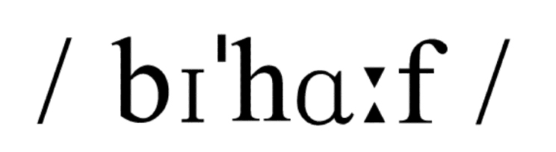
noun
- on behalf of somebody / on sb’s behalf
εκ μέρους κάποιου
American English: in behalf of
- instead of someone, or as their representative
On behalf of my mother I’d like to thank you for the lovely presents.
She spoke at the meeting on my behalf.
/ bɪnɒkj ləz, baɪnɒkj ləz /
ə
^{ʊ}

ə
^{ʊ}

binoculars
[εικόνα]
noun (plural)
- a pair of special glasses, that you hold up to your eyes to look at objects that are a long distance away
κιάλια
ￚ synonym: field glasses

borrow
/ bɒrəʊ /
verb (intransitive and transitive)
- to use something that belongs to someone else and that you must give back to them later or to take or copy someone's ideas, words etc and use them in your own work, language etc
δανείζομαι
May I borrow your pen? He borrowed from the bank to build a new house.
I borrowed my ideas from a poem.

C
/ sentə /
centre British English
/ sentər /
center American English
noun
- (countable usually singular) the middle of a space, area, or object
κέντρο
There was an enormous table in the centre of the room.
The hotel is right in the centre of the village.
- (countable) a building which is used for a particular purpose or activity
κέντρο ( κτίριο )
the European Centre for Tourism
a shopping centre the new Health Centre
an exhibition of modern painting at the local Arts Centre
a conference centre
- (countable) a place where there is a lot of a particular type of business, activity etc business/commercial/financial
κέντρο («πυρήνας», σημείο δραστηριότητας)
Paris is a cultural centre.
- (countable) British English the part of a town or city where most of the shops, restaurants, cinemas, theatres etc are
κέντρο (της πόλης)
We live in the town centre.
Are cars allowed in the centre of the city?
American English: downtown town/city centre
- be at the centre of something= if a person or thing is at the centre of something that is happening, they are involved in it more than other people or things
κέντρο (επίκεντρο)
Why don’t you ask Mary? She is always at the centre of things.
- be the centre of attention / interest
to be the person that everyone is giving attention to
Max is so naughty in class because he wants to be the centre of attention.

colour British English
/ kʌlə /
/ kʌlər /
color American English
noun
- (countable) red, blue, yellow, green, brown, purple etc
χρώμα
What colour shoes are you wearing? What colour is your hair?
light / bright / pastel etc colour
I love wearing T-shirts with bright colours.
- (uncountable and countable) a substance such as paint or dye that makes something red, blue, yellow etc
χρώμα (χρωστική ουσία)
We’ll buy some blue colour to paint those old chairs.
- in (full) colour a television programme, film, or photograph that is in colour contains colours such as red, green, and blue rather than just black and white
έγχρωμος
ￚ opposite: in black and white

come
/ kʌm /
verb, (intransitive) past tense: came, past participle: come
έρχομαι

come out phrasal verb
- if something comes out, it is removed from a place
αφαιρώ
Do you know how this stain will come out?
- if information comes out, people learn about it, especially after it has been kept secret
κυκλοφορώ
He is worrying that the truth will come out.
- if a photograph comes out, it shows a clear picture
εμφανίζω
The photos of our holidays have come out.
- if a book, record etc comes out, it becomes publicly available
εκδίδω
A new book about Ancient Greece is coming out.
- if something comes out in a particular way, that is what it is like after it has been made or produced
βγαίνει αποτέλεσμα
I've made a cake, but it hasn't come out very well.
- if a flower comes out, it opens
ανθίζω
A lot of flowers come out in spring.
- appear
εμφανίζομαι
The stars come out at night.

compass
/ kʌmpəs /
noun
- (countable) an instrument that shows directions and has a needle that always points north
πυξίδα
The climbers used their compass to find their way back to the village.
compass points/points of the compass (= the marks on a compass that show you north, south, east, west)
- (countable) also: compasses a V-shaped instrument with one sharp point and a pen or pencil at the other end, used for drawing circles or measuring distances on maps
διαβήτης
/ kəmpleɪn /
complain (about)
verb (intransitive, transitive not in passive)
- to say that you are annoyed, not satisfied, or unhappy about something or someone
παραπονιέμαι
“You don’t love me”, she complained.
She complained that there was a hole in her new blouse.
She never complains about working so hard.
Antony often complains of stomachache.
Mrs Derek complained to her neighbours about the noise.

compress
/ kɒmpres /
noun (countable)
- a small thick piece of material that you put on part of someone's body to stop blood flowing out or to make it less painful
κομπρέσα
cold / hot compress
A cold compress will help you feel better.

conserve
/ kənsɜv /
verb (transitive)
- to protect something and prevent it from changing or being damaged or to use as little water, energy etc as possible so that it is not wasted
προφυλάσσω, προστατεύω διατηρώ, συντηρώ
We must conserve the rainforests in the Amazon.
ￚ synonym: preserve

crutch
/ krʌt /
noun (countable), plural: crutches
- (usually plural) one of a pair of long sticks that you put under your arms to help you walk when you have hurt your leg
πατερίτσα
- be / walk on crutches (= use crutches)
My cousin broke his leg and was on crutches for two months.
/ kʌlt veɪt /
ə
ɪ
cultivate
verb (transitive)
- to prepare and use land for growing crops and plants
καλλιεργώ (τη γη)
My uncle John is a farmer and cultivates land.
He cultivates tomatoes in the summer.
- synonym: grow
- to work hard to develop a particular skill, attitude, or quality
καλλιεργώ (βελτιώνω, προάγω)
The teacher cultivates good relationships in class.

culture
/ kʌltə /
noun
- (uncountable and countable) the beliefs, way of life, art, and customs that are shared and accepted by people in a particular society
κουλτούρα, πολιτισμός
At school we learn about the Greek culture.
In some cultures, you shouldn’t touch women’s hands.
- (uncountable and countable) the attitudes and beliefs about something that are shared by a particular group of people or in a particular organization
κουλτούρα, «πνεύμα»
The new employee has to be informed about the company culture.
- (uncountable) activities that are related to art, music, literature etc
πολιτιστική κληρονομιά, πολιτιστική παράδοση
These old churches are part of our culture.
D
daughter-in-law

noun (countable), plural: daughters-in-law
- your son's wife
νύφη (σύζυγος του γιου)
/ dɪpɑtə /
departure
noun (uncountable and countable)
- an act of leaving a place, especially at the start of a journey
αναχώρηση
We organized a farewell party before their departure for Australia.
Is there a delay in the departure of our flight?
His departure from Argentina left everyone surprised.
ￚ opposite: arrival

destination
/ dest neɪən /
ə
ɪ
noun (countable)
- the place that someone or something is going to
προορισμός
It’s a five-hour journey to get to your destination.
holiday / tourist destination
Santorini is a popular tourist destination.
/ daɪæm tə /
ə
ɪ
diameter British English
/ daɪæm tər /
ə
ɪ
diameter American English
noun (countable)
- a straight line from one side of a circle to the other side that passes from the centre and divides the circle in half
διάμετρος
Draw a circle ten centimetres in diameter.

E
/ ɪksteɪndʒ /

exchange
noun
- (uncountable and countable) the act of giving someone something and receiving something else from them
αντάλλαγμα
I offered to wash the car in exchange for a nice meal.

- (countable) the act of giving something you have bought back to the store where you bought it, for example because it does not work, fit etc, and taking something else instead
αλλαγή
I would like to exchange this skirt. It’s too short for me.
- (uncountable) a process in which you change money from one currency to another
συνάλλαγμα
What is the exchange rate for the dollar today?.
- (countable) an arrangement in which a student, teacher etc visits another school or university to work or study
ανταλλαγή
Ten students have come here on an exchange programme.

expedition
/ eksp dɪən /

ə
ɪ
noun (countable)
- a long and carefully organized journey, especially to a dangerous or unfamiliar place, or the people that make this journey
αποστολή
He’s going on an expedition to Africa.

explode
/ ɪkspləʊd /

verb
- (intransitive and transitive) to burst, or to make something burst, into small pieces, usually with a loud noise and in a way that causes damage
σκάω, εκρήγνυμαι
The bomb exploded near the bus station.
- (intransitive) to suddenly express strong feelings such as anger
«εκρήγνυμαι» (μεταφορικά), ξεσπώ
We exploded with laughter after his joke.

F
fabric
/ fæbrɪk /
noun (uncountable and countable)
- cloth used for making clothes, curtains etc
ύφασμα
ￚ synonym: material
/ fæənəbəl /
fashionable
adjective
- popular, especially for a short period of time
μοντέρνος
Big hats aren’t fashionable now.
ￚ opposite: unfashionable

favourite British English
/ feɪvər t /
ə
ɪ
favorite American English
adjective (only before noun)
- your favourite person or thing is the one that you like the most
αγαπημένος
What's your favourite colour?

fee
/ fi /
noun (countable)
- an amount of money that you pay to do something or that you pay to a professional person for their work
αμοιβή
school fees entrance / entry fee (= fee to enter a place)
doctor's/lawyer's/accountant's fees
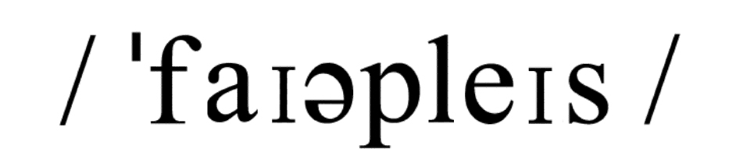
fireplace
noun (countable)
- a special place in the wall of a room, where you can make a fire
τζάκι

flight

noun
- (countable) a journey in a plane or space vehicle, or the plane or vehicle that is making the journey
πτήση
He booked a flight to Rome for his wife.
She caught the first flight to Athens to meet her grandchildren.
We took a taxi in order not to miss our flight.
- (countable) a set of stairs between one floor and the next
σκάλα
- a flight of stairs / steps

flipper [εικόνα]
noun (countable)
- a kind of broad, plastic shoe that you wear to help you swim fast under water βατραχοπέδιλο
a pair of flippers
- a broad, flat part of the body which some sea animals have and which helps them to swim
πτερύγιο
Penguins have flippers.

G
/ greɪtfəl /
grateful
adjective
- feeling that you want to thank someone because of something kind that they have done, or showing this feeling
ευγνώμων
I'm so grateful to you for all your help.
extremely / deeply / eternally grateful
I am extremely grateful for your support.
ￚ opposite: ungrateful

H
/ hɒl di, -deɪ /
ə
ɪ
holiday
noun
- (uncountable and countable) British English, also: holidays a time of rest from work, school etc
διακοπές, άδεια
The school holidays start tomorrow.
Lena isn’t here. She is away on holiday.
American English: vacation
- (uncountable and countable) British English, also: holidays a period of time when you travel to another place for pleasure
περίοδος διακοπών
We're going to Spain for our holidays.
When are you going on holiday?
American English: vacation
- (countable) a day fixed by law on which people do not have to go to work or school
αργία
The 28th of October is a national holiday in Greece.

I
insurance
/ ɪnʊərəns /
noun
- (uncountable) an arrangement with a company in which you pay them money, especially regularly, and they pay the costs if something bad happens, for example if you become ill or your car is damaged
ασφάλιση, ασφάλεια
health / car / travel etc insurance
(uncountable) the business of providing insurance
ασφαλιστική εταιρεία
My husband works in an insurance company.
- (uncountable) British English the money that you pay regularly to an insurance company
ασφάλιστρα
How much is the insurance on your car?
ￚ synonym: insurance premium

J
jar [εικόνα]
/ dʒɑ /
noun (countable)
- a glass container with a wide top and a lid, used for storing food such as jam or honey, or the amount it contains
βάζο με καπάκι
The jars of jam are on the top shelves.
- a container made of clay, stone etc used especially in the past for keeping food or drink in
κανάτα
a jar of water

journey
/ dʒɜni /
noun (countable)
- British English a time spent travelling from one place to another, especially over a long distance
ταξίδι, διαδρομή
My journey to Egypt was an unforgettable experience.
They decided to go on a journey across Europe.
We saw a lot of wild animals on the journey.
It’s a two-hour journey from Athens to Patras by car.
American English: trip

K
kit
/ kɪt /
noun
- (countable) a set of tools, equipment etc that you use for a particular purpose or activity
κουτί, σύνεργα
make-up kit a bike repair kit a shaving kit a first aid kit a tool kit
- (countable) something that you buy in parts and put together yourself
σύνολο τεμαχίων για συναρμολόγηση
model kits for making boats
kit cars
- (uncountable and countable) British English a set of clothes and equipment that you use for a particular purpose such as playing a sport
εξοπλισμός
sports kit
football kits
- (uncountable) a set of clothes and equipment used by soldiers, sailors, etc
εξάρτυση

L
/ lɑst /
last
determiner, adjective
- most recent or nearest to the present time
τελευταίος
Did you see the new show on TV last night?
- happening or existing at the end, with no others after
I’m writing the last page of the report.
ￚ opposite: first
- remaining after all others have gone, been used etc
She always wants to have the last word.
- the last minute / moment
the latest possible time before something happens
She changed her mind about the wedding at the last minute.
- the last person / thing
used to make a strong negative statement about someone or something
The last thing I want now is talking to Peter.

leather
/ leðə /
noun [uncountable]
- animal skin used for making shoes, bags etc
δέρμα
a leather belt leather shoes

look for
verb (transitive)
- to try to find something or someone
ψάχνω
Could you help me look for my keys?
He’s been looking for Jane. Do you know where she is?

luggage
/ lʌgɪdʒ /
noun (uncountable)
- the suitcases, bags etc that you carry when you travel
αποσκευές
They lost their luggage at the airport.
American English: baggage

M
made

- the past tense and past participle of make
φτιαγμένο
factory-made / German-made / homemade etc = made in a factory / in Germany / at home etc
- it’s made of
This table is made of wood.
/ mæs /
mass
noun plural : masses
- (countable) a large amount of a substance or quantity of something which does not have a definite or regular shape
μάζα
a mass of iron
masses of something
British English (informal) a large amount of something, or a lot of people or things πολλά
Masses of books were lying on the floor.
- (singular) a large crowd
πλήθος
- mass of
There was a mass of people outside the stadium.
- (uncountable and countable) also: Mass the main ceremony in some Christian churches, especially the Roman Catholic Church, which celebrates the last meal that Jesus Christ ate
λειτουργία
Everybody in the village attended the Christmas mass.
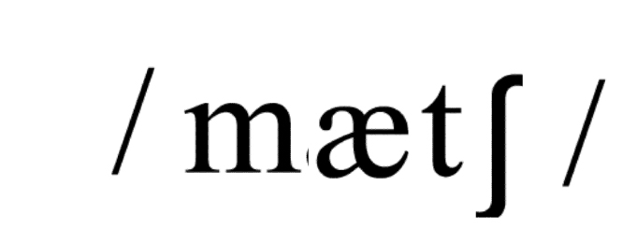
match
verb
- (intransitive and transitive) if one thing matches another, or if two things match, they look attractive together because they are a similar colour, pattern etc
ταιριάζω, συνδυάζω
This green tie doesn’t match with the blue suit.
- (intransitive and transitive) if two things match, or if one matches the other, there is no important difference between them
μοιάζω, είμαι παρόμοιος
The girl in the photo matches with the girl we met last night.
- (transitive) to be suitable for a particular person, thing, or situation
είμαι ταιριαστός, είμαι κατάλληλος
You should choose a class that matches your interests.
ￚ synonym: suit
- (transitive) to put two people or things together that are similar to or somehow connected with each other
αντιστοιχώ
- match something to / with something
Match the animals to the right pictures.

microwave / maɪkrəweɪv /
noun (countable)
- a very short electric wave that is used in cooking food and sending messages by radio, and in radar
μικροκύμα

- microwave oven = a type of oven that cooks food very quickly using very short electric waves instead of heat
φούρνος μικροκυμάτων

N
/ nefju, nevju /
nephew
noun (countable)
- the son of your brother or sister
ανιψιός

niece
/ nis /
noun (countable)
- the daughter of your brother or sister
ανιψιά

O
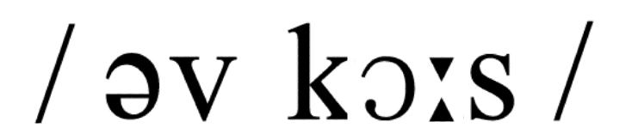
of course
adverb
- used to show that other people probably already know what you are saying is true, or expect to hear it
φυσικά, βέβαια
Will you come with me? -0f course.
Of course Ben didn’t know the truth.

ointment [εικόνα]
/ ɔɪntmənt /
noun (uncountable and countable)
- a soft cream that you rub into your skin, especially as a medical treatment
αλοιφή
/ ɔbɪtl /

orbital
adjective
- relating to the orbit of one object around another
αυτός που αναφέρεται στην τροχιά
the Earth's orbital path
- British English an orbital road goes around a large city
περιφερειακός
To avoid traffic jams they constructed an orbital motorway.

- orbital velocity = minimal velocity needed to place something in orbit

P
/ pætən /
pattern
noun (countable)
- the regular way in which something happens, develops, or is done
δομή
As a psychologist he studies different behaviour patterns.
- a regularly repeated arrangement of shapes, colours, or lines on a surface, usually as decoration
σχέδιο, μοτίβο
His shirt had a pattern of yellow and red stripes.
- (usually singular) a thing, idea, or person that is an example to copy
πρότυπο, υπόδειγμα.
- a shape used as a guide for making something, especially a thin piece of paper used when cutting material to make clothes
πατρόν
a dress pattern
- a small piece of cloth, paper etc that shows what a larger piece will look like
δείγμα
ￚ synonym: sample

pick
/ ɪ k /

pick up
verb (transitive)
- pick something up to lift something or someone up
σηκώνω
He picked up the pieces of the broken vase.
The phone rang and I picked it up.
- pick somebody up to collect someone from somewhere
παίρνω (με όχημα)
Mummy, can you pick me up from the bus station?
- pick yourself up to get up from the ground after you have fallen
σηκώνομαι
He picked himself up and rode his bike again.

price
/ praɪs /

noun
- (uncountable and countable) the amount of money you have to pay for something τιμή
What is the price of this bag?
Prices have gone up this week. They sell clothes at very good prices here.
- (singular) the unpleasant things that you must suffer in order to be successful, free etc
τίμημα
She doesn’t have a private life. That’s the price she pays for being famous.
- half / full price
used to talk about half the usual price of something, or the actual usual price
I bought this set of tea cups at half price.
- at a price
for a lot of money
- price tag = label for showing prices

print
/ prɪnt /
verb
- (intransitive and transitive) to produce words, numbers, or pictures on paper, using a machine which puts ink onto the surface
τυπώνω, δημοσιεύω
He printed the letter after he had finished writing it.
My article was printed in the local newspaper.
- (transitive) to produce a photograph from a photographic film
τυπώνω φωτογραφία (από αρνητικό)
He decided to print the photos he had taken on his holiday.
- (intransitive and transitive) to write words by hand without joining the letters
γράφω καθαρά
Please print your name on the first page of your test.
- (transitive) to make a mark on a surface or in a soft substance by pressing something on to it
αποτυπώνω, εντυπώνω, χαράσσω
The name of the famous actor was printed on the wall.

purpose
/ pɜpəs /
noun
- (countable usually singular) the purpose of something is what it is intended to achieve
σκοπός
What is the purpose of your trip?
She sold her house for the purpose of buying a bigger one.
He began his studies with the purpose of becoming a doctor.
- serve a purpose (= achieve a particular aim)
It would serve my purpose to study Public Relations.
- on purpose (= deliberately)
I didn’t do it on purpose.

Q
/ kwɒl ti /
ə
ɪ
quality
noun, plural: qualities
- (uncountable and countable) how good or bad something is
ποιότητα
This leather handbag is of very good quality.
- (countable, usually plural) something that people may have as part of their character, for example courage or intelligence
προτέρημα
His qualities are patience and self-confidence.
- (countable) something that is typical of one thing and makes it different from other things, for example size, colour etc
ιδιότητα
What are the qualities of this metal?
- quality of life (= how good or bad your life is, shown for example by whether or not you are happy, healthy, able to do what you want etc)

R
reach
/ rit /
verb
- (intransitive, transitive always + adverb/preposition) to move your arm in order to touch or lift something with your hand
απλώνω (το χέρι) για να φτάσω
Can you reach the tomato juice cans on the top shelf?
- (intransitive always + adverb/preposition, transitive not in progressive) to be big enough, long enough etc to get to a particular point
εκτείνομαι σε μήκος
The garden of my house reaches as far as the beach.
- (transitive) to arrive at a place
φτάνω (στον προορισμό μου)
The train will reach Moscow in two hours.
- (transitive) if you reach someone, you succeed in speaking to them on the telephone
επικοινωνώ (μέσω τηλεφώνου)
You can reach me on 6798754678 any time you want.
ￚ synonym: contact
- reach a decision / agreement etc
(transitive) to successfully agree on something with other people
επιτυγχάνω, κατορθώνω
An agreement was reached between the two countries.

respect
/ rɪspekt /

noun
- (uncountable) when you admire someone, especially because of their personal qualities, knowledge, or skills
σεβασμός, υπόληψη
You should have respect for older people.
- win / earn / gain the respect of somebody
He has earned the respect of his students.
ￚ opposite: disrespect
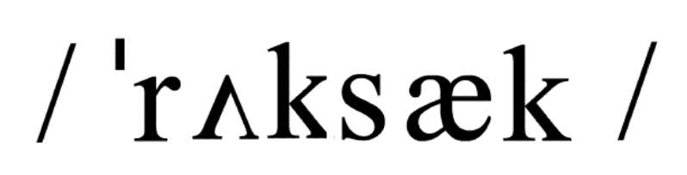
rucksack
noun (countable)
- especially British English a bag used for carrying things on your back, especially by people on long walks
σακίδιο πλάτης
ￚ synonym: backpack

S
/ sæt laɪt /
ə
ɪ
satellite [εικόνα]
noun (countable)
- a natural object that moves around a planet or a machine that has been sent into space and goes around the Earth, moon etc, used for radio, television, and other electronic communication
δορυφόρος (φυσικός ή τεχνητός )
The moon is a satellite of the Earth.
- via / by satellite (= using a satellite)
They took some photos of the island via satellite.

sausage
noun (uncountable and countable)
- a small tube of skin filled with a mixture of meat, spices etc, eaten hot or cold after it has been cooked
λουκάνικο
/ slɪm /
slim
adjective, comparative: slimmer, superlative: slimmest
- someone who is slim is attractively thin
αδύνατος, καλλίγραμμος
If you want a slim figure you should exercise regularly.
- synonym: slender
- very small in amount or number
μικρός, λίγος
There's a slim chance that Sonia will come tonight.

snorkel
/ snɔkəl /
noun (countable)
- a tube that allows someone who is swimming to breathe air under water
αναπνευστήρας
/ səʊlə /
solar
adjective (only before noun)
- relating to the sun or using the power of the sun's light and heat
ηλιακός
In Greece we use solar energy to get hot water.
the solar system = the sun and the planets which revolve round it
/ speɪs-sut, speɪs-sjut /
spacesuit
[εικόνα]
noun (countable)
- a special protective suit that people wear in space, that covers the whole body and provides a supply of air
στολή αστροναύτη
/ stil /
steal
/ stəʊlən /
/ stəʊl /
verb, past tense: stole past participle: stolen
- (intransitive and transitive) to take something that belongs to someone else
κλέβω
Someone has stolen my purse!.
- steal from
He stole some jewellery from the shop.
- (intransitive always + adverb/preposition) to move quietly without anyone noticing you
ξεγλιστρώ, απομακρύνομαι χωρίς να γίνω αντιληπτός
He stole out of the room while his wife was sleeping.
ￚ synonym: creep
- steal the show / limelight / scene to do something, especially when you are acting in a play, that makes people pay more attention to you than to other people
κλέβω την παράσταση, εντυπωσιάζω
Nora stole the show when she sang.
steal a look / glance etc to look at someone or something quickly and secretly
stitch
/ stɪt /
noun
- (countable) a short piece of thread that has been sewn into a piece of cloth, or the action of the thread going into and out of the cloth
βελονιά
- (countable) a piece of special thread which has been used to sew the edges of a wound together
ράμμα
She cut her knee and put ten stitches.
- (countable) a small circle of wool that is formed around a needle when you are knitting
πόντος
- drop a stitch (= lose a stitch because the wool has come off the needle)

surgeon
/ sɜdʒən /
noun (countable)
- a doctor who does operations in a hospital
χειρουργός

T
take care of
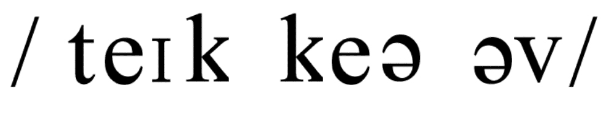
expression
- be responsible for
φροντίζω

take part in
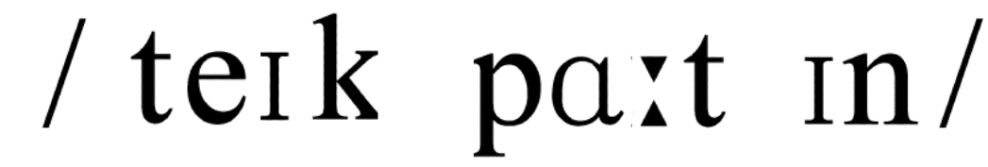
expression
- have a share in, help
συμμετέχω

temperature
/ tempərətə /
noun
- (uncountable and countable) a measure of how hot or cold a place or thing is
θερμοκρασία
There will be a rise in temperature next week. The doctor took my temperature.
- have a temperature to have a body temperature that is higher than normal, especially because you are sick
πυρετός
If you have a temperature you had better stay in bed.

thank
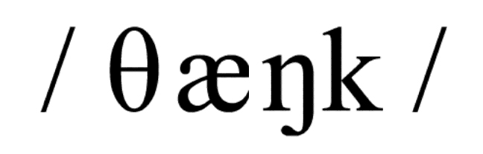
verb
- used to tell someone that you are grateful for something they have given you or done for you
ευχαριστώ
I helped her carry her heavy bag and she thanked me.
ￚ synonym: thanks
- thank you for (doing) something
They thanked him for driving them home.
/ θɪŋk /
think
/ θɔt /
verb, past tense and past participle: thought
- use my mind to produce an idea, name, suggestion
σκέφτομαι
She thought a lot before answering the question.
think of somebody/something
Will you think of me when you go to Australia?
think about something
He is thinking about changing his job
consider, be of the opinion
νομίζω
He thinks that Anna is in love with him.

torch
/ tɔt /
noun (countable), plural: torches
- British English a small electric lamp that you carry in your hand
φακός
We used our torches to see into the dark room.
American English: flashlight
- a long stick with burning material at one end that produces light
δάδα
the Olympic torch

travel
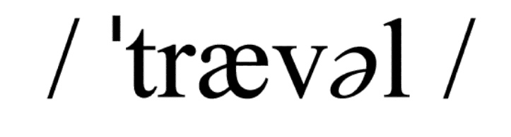
verb, past simple and past participle: travelled, present participle: travelling
American English: past simple and past participle: traveled, present participle: traveling
- to go from place to place
ταξιδεύω
She has been travelling for over a month.
to move along
κινούμαι με ταχύτητα
Light travels very fast.

travelling
/ trævəlɪŋ/
noun ( uncountable)
- used or designed for travels
ταξίδι , ταξίδια
She enjoys travelling.
travelling expenses a travelling bag
American English: traveling
/ tred mɪl/
treadmill
noun (countable)
- a piece of exercise equipment that you can walk or run on
διάδρομος
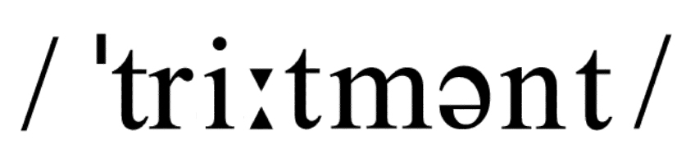
treatment
noun
- (uncountable and countable) something that is done to cure someone who is injured or ill
θεραπεία , θεραπευτική αγωγή
He is under treatment for a rare blood disease.
- (uncountable) a particular way of behaving towards someone or of dealing with them
μεταχείριση, συμπεριφορά
This student needs special treatment.
/ traɪb /
tribe
noun (countable)
- a social group consisting of people of the same race who have the same beliefs, customs, language etc, and usually live in one particular area ruled by their leader
φυλή
My uncle, who is an anthropologist, is studying an Indian tribe.

try
/ traɪ /
verb, past tense and past participle: tried, present participle: trying, third person singular: tries
- (intransitive and transitive) to attempt to do or get something
προσπαθώ, δοκιμάζω
Try to do this exercise later when you feel better.
- try something on to put on a piece of clothing to see if it fits you
προβάρω (ρούχο)
- try something for size (= put on a piece of clothing or test something to find out if it is the correct size or suitable)
δοκιμάζω αν κάτι είναι στα μέτρα μου
- (transitive) to taste food or drink to find out if you like it
δοκιμάζω (φαγητό)
Would you like to try my chicken soup?
ￚ synonym: taste
- (transitive usually passive) to examine and judge a legal case, or someone who is thought to be guilty of a crime in a court
δικάζω
- be tried for something
She was tried for murder.

tube
/ tjub /
noun
- (countable) a round pipe made of metal, glass, rubber etc, especially for liquids or gases to go through
σωλήνας
- (countable) a narrow container made of plastic or soft metal and closed at one end, that you press between your fingers in order to push out the soft substance that is inside
σωληνάριο
Don’t forget to buy a tube of toothpaste.
- the tube British English the system of trains that run under the ground in London
υπόγειος σιδηρόδρομος , μετρό
- take / catch the tube
He goes to work by tube.
American English: subway

U
/ jun vɜs /
ə
ɪ
universe
noun
- the universe all space, including all the stars and planets
υφήλιος, σύμπαν, οικουμένη
- in the universe
- be the centre of somebody's universe
to be the most important person or thing to someone
- somebody’s universe
a person's life, including all of the people, places, and ideas which affect them

V
ə
ɪ
/ v lɒs ti /
ə
ɪ
velocity
noun (countable and uncountable)
- the speed of something that is moving in a particular direction
ταχύτητα

volume
/ vɒljum /
noun
- (uncountable) the amount of sound produced by a television, radio etc
ένταση, ήχος
- turn the volume up / down
Turn the volume down! I can’t hear anything!
- (countable usually singular, uncountable) the total amount of something, especially when it is large or increasing
όγκος, μεγάλη ποσότητα
The volume of homework increases in exam classes.
- (countable usually singular) a measurement of the amount of space that a substance or object fills, or the amount of space in a container
όγκος
What is the volume of water in this tank?
- (countable) a book that is part of a set, or one into which a very long book is divided
τόμος
This is the 10th volume of the encyclopedia.
- all the copies of a particular magazine printed in one particular year
τεύχος

W
/ wɔdrəʊb /
wardrobe
noun
- (countable) British English a piece of furniture like a large cupboard that you hang clothes in
ντουλάπα
She hangs all her clothes in the wardrobe.
- (countable) the clothes that someone has
γκαρνταρόμπα ( σύνολο ρούχων )
Top models renew their wardrobe very often.
winter / summer etc wardrobe (= the clothes you have for a particular time of year)

wedding
/ wedɪŋ /
noun (countable)
- a marriage ceremony, especially one with a religious service
γαμήλια τελετή
My friend Jenny invited me to her wedding.
wedding party / reception / breakfast
a wedding present the wedding cake wedding anniversary
a wedding dress (= the dress worn by a woman who is getting married)
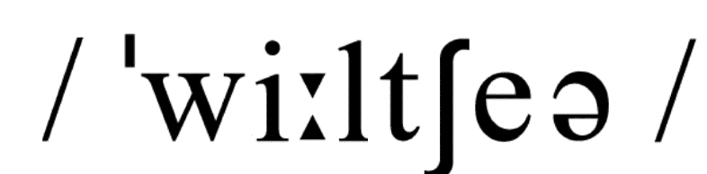
wheelchair
noun (countable)
- a special chair with big wheels, used by people who cannot walk
αναπηρικό καροτσάκι
After the accident he has been in a wheelchair.

wound
/ wund /
noun (countable)
- an injury to your body that is made by a weapon such as a knife or a bullet
τραύμα, πληγή
He had a small wound in his leg.
- a feeling of emotional or mental pain that you get when someone says or does something unpleasant to you
ψυχικό τραύμα

wrap
/ ræp /
verb, past tense and past participle: wrapped, present participle: wrapping
(transitive)
- also: wrap up to put paper or cloth over something to cover it
τυλίγω
The shop assistant wrapped up the book.
She wrapped the blanket around her body.
He was wrapped in warm clothes.

X
X-ray
/ eks reɪ /
noun (countable)
- a photograph of part of someone's body, taken using X-rays to see if anything is wrong
ακτινογραφία
The X-ray showed that her leg was not broken.

Y
yacht
/ jɒt /

noun (countable)
- a large boat with a sail, used for pleasure or sport, especially one that has a place where you can sleep
σκάφος αναψυχής

yawn
/ jɔn /

verb (intransitive)
- to open your mouth wide and breathe in deeply because you are tired or bored
χασμουριέμαι
He opened his mouth and yawned.

yell
/ jel /

verb [intransitive and transitive]
- also: yell out to shout or say something very loudly, especially because you are frightened, angry, or excited
φωνάζω
“Go out!” the angry man yelled.

year
/ jɪə, jɜ /

noun (countable)
- a period of about 365 days or 12 months
έτος, χρόνος
He has been working in this company for three years.
My son is six years old. Denise has a ten-year-old daughter.
all (the) year round
όλο το χρόνο
The museum is open all year round.
years (informal) a very long period of time
χρόνια
It's years since I last met Bob.
She hasn’t been to the cinema for years.
It was the first time in years he felt so happy.
ￚ synonym: ages

yesterday
/ jestədi, jestədeɪ /

adverb
- on or during the day before today
χθες
I met Nick outside the bank yesterday.
yesterday morning / afternoon / evening
/ jɒgət /

yoghurt [εικόνα]
noun (uncountable and countable)
- a thick liquid food that tastes slightly sour and is made from milk, or an amount of this food
γιαούρτι
There are two pots of yoghurt in the fridge.
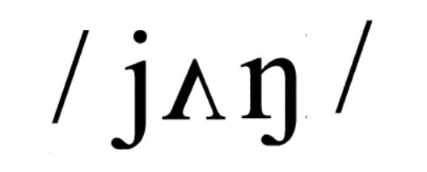
young
adjective, comparative: younger, superlative: youngest
- a young person, plant, or animal has not lived for very long
νέος
Ron is a fine young man. My sister is younger than me.
/ jet /

yet
adverb
- used in negative statements and questions to talk about whether something that was expected has happened
ακόμα (σε αρνητικές και ερωτηματικές προτάσεις)
I haven't cooked yet. I will do it later.
Has he met Doris yet?
“Have you finished painting the walls?” “Not yet.”
- used to emphasize that something is even more than it was before or is in addition to what existed before
ακόμα (σε καταφατικές προτάσεις για έμφαση)
You have yet more time to pack your suitcases.
ￚ synonym: still

Z
zebra [εικόνα]
/ zibrə /

noun (countable)
- an animal that looks like a horse but has black and white lines all over its body
ζέβρα

zero
/ zɪərəʊ /

/

number, plural: zeros or zeroes
- the number 0
μηδέν (αριθμός)
The temperature was at zero last night.
British English: nought

zip
/ zɪp /

/

noun (countable)
- British English two lines of small metal or plastic pieces that slide together to fasten a piece of clothing
φερμουάρ
Can you help me?The zip on my dress got stuck.
- do up κλείνω το φερμουάρ
- undo a zip ανοίγω το φερμουάρ
American English: zipper

zoo

noun (countable), plural: zoos
- a place, usually in a city, where animals of many kinds are kept so that people can go to look at them
ζωολογικός κήπος

Thematic vocabulary

Universe
/ eɪlien /
alien [εικόνα]
noun
- a creature living on another planet not on Earth
εξωγήινος
/ æstrənɔt /
astronaut [εικόνα]
noun
- a person who travels in a spaceship
αστροναύτης
/ ɜθ/
earth [εικόνα]
noun
- the planet on which we live
γη
- the Earth
/ gæləksi /
galaxy [εικόνα]
noun (plural: galaxies)
- a group of stars in space
γαλαξίας

moon [εικόνα]
/ mun /
noun
- the body that moves round the earth and shines at night
φεγγάρι, σελήνη
- the Moon

spaceship [εικόνα]
/ speɪsɪp /
noun
- the vehicle you need to travel in space (beyond earth’s atmosphere)
διαστημόπλοιο
/ sʌn /
sun [εικόνα]
noun
- the body which shines in the day and from which the Earth gets light
ήλιος
- the Sun
/ tel skəʊp /
ə
ɪ
telescope [εικόνα]
noun
- an instrument with special lenses used for observing distant objects
τηλεσκόπιο

Sports
/ kənuɪŋ /
canoeing [εικόνα]
noun
- a sport in which you move a light boat by using one paddle
κανό
/ fensɪŋ /
fencing [εικόνα]
noun
- a sport in which you fight with swords
ξιφασκία
/ dʒɪmnæstɪks /
gymnastics [εικόνα]
noun (plural)
- body exercises to keep fit
γυμναστική
- do gymnastics

hammer throw [εικόνα]
/ hæmə θrəʊ /
noun
- a sport in which you throw a heavy metal ball fixed to a chain
σφυροβολία
/ hɑɪ dʒʌmp /
high jump [εικόνα]
noun
- practice of physical exercise in jumping
άλμα εις ύψος
/ hɔs raɪdɪŋ /
horse riding [εικόνα]
noun
- a sport in which you ride a horse
ιππασία

water polo [εικόνα]
/ wɔtə pəʊləʊ /
noun (uncountable)
- game played by two teams of swimmers throwing a ball into a goal
υδατοσφαίριση

weightlifting [εικόνα]
/ weɪtlɪf tɪŋ /
noun
- a sport in which you lift heavy metal pieces
άρση βαρών

Tools
axe, ax [εικόνα]
/ æks /
noun (countable) plural: axes
- tool for cutting down trees or cutting wood
τσεκούρι

brush [εικόνα]
/ brʌ /
noun
- tool made of wire, hair used for cleaning, sweeping, painting
βούρτσα, πινέλο

hammer [εικόνα]
/ hæmə/
noun (countable)
- tool with a heavy metal part used for breaking things and nailing
σφυρί
/ reɪk/
rake [εικόνα]
noun (countable)
- tool with a long handle used for smoothing soil or drawing together straw, leaves etc.
τσουγκράνα
/ sɔ/
saw [εικόνα]
noun (countable)
- tool with sharp edge for cutting wood
πριόνι
/ skrudraɪvə/
screwdriver [εικόνα]
noun (countable)
- tool for turning screws
κατσαβίδι
/ speɪd/
spade [εικόνα]
noun (countable)
- tool for digging
φτυάρι
/  traʊəl /
trowel [εικόνα]
noun (countable)
- tool with a flat blade used for spreading mortar on stone, bricks wall
μυστρί, σπάτουλα

Luggage
/ bɪnɒkj ləz, baɪnɒkj ləz /
ə
^{ʊ}

ə
^{ʊ}

binoculars
[εικόνα]
noun (plural)
- a pair of special glasses, that you hold up to your eyes to look at objects that are a long distance away
κιάλια
ￚ synonym: field glasses

camera [εικόνα]
/ kæmərə /
noun (countable)
- a device for a taking photographs
φωτογραφική μηχανή

compass [εικόνα]
/ kʌmpəs /
noun
- (countable) an instrument that shows directions and has a needle that always points north
πυξίδα
The climbers used their compass to find their way back to the village.
compass points/points of the compass (= the marks on a compass that show you north, south, east, west)

flipper [εικόνα]
noun (countable)
- a kind of broad, plastic shoe that you wear to help you swim fast under water
βατραχοπέδιλο
a pair of flippers

guide book [εικόνα]
/ gaɪdbʊk /
noun (countable)
- a book for tourists with information about a place
ταξιδιωτικός οδηγός

map [εικόνα]
/ mæp /
noun (countable)
- a piece of paper showing countries, oceans, mountains etc.
χάρτης

medical kit [εικόνα]
/ medɪkəl kɪt /
noun
- a small box to carry medical equipment
φαρμακείο
/ məʊbaɪl fəʊn /
mobile phone [εικόνα]
noun
- a portable phone easily moved
κινητό τηλέφωνο

passport [εικόνα]
/ pɑspɔt /
noun (countable)
- an official document we carry when we travel abroad
διαβατήριο
/ peɪfəʊn kɑd /
payphone card [εικόνα]
noun (countable)
- a card used in a card-operated telephone box
τηλεκάρτα
/ fəʊtəʊ /
photo [εικόνα]
noun (countable), photograph
- a picture of someone or something we take by using a camera
φωτογραφία

rucksack [εικόνα]
noun (countable)
- especially British English a bag used for carrying things on your back, especially by people on long walks
σακίδιο πλάτης
ￚ synonym: backpack

sleeping bag [εικόνα]
/ slɪpɪŋ bæg /
noun (countable)
- a warm bag in which we sleep when we go camping
υπνόσακος

snorkel [εικόνα]
/ snɔkəl /
noun (countable)
- a tube that allows someone who is swimming to breathe air under water
αναπνευστήρας

souvenir [εικόνα]
/suvənɪə /
noun (countable)
- something bought on a trip to remind us of a place we visited
ενθύμιο
/ stætu /
statue [εικόνα]
noun (countable)
- figure of a person, animal in wood or stone
άγαλμα
statue souvenir (= αναμνηστικό αγαλματάκι)

suitcase [εικόνα]
/ sutkeɪs/
noun (countable)
- where we put our clothes when we travel
βαλίτσα
ə
ɪ
/ sʌnglɑs z /
sunglasses [εικόνα]
noun (plural)
- glasses to protect the eyes from the sun
γυαλιά ηλίου
ə
ɪ
/ tɪke t /
ticket [εικόνα]
noun (countable)
- a small piece of paper used to travel in a train, bus etc.
εισιτήριο

torch [εικόνα]
/ tɔt /
noun (countable), plural: torches
- British English a small electric lamp that you carry in your hand
φακός
We used our torches to see into the dark room.
American English: flashlight

Shopping (clothes, accessories, etc.)
/ belt /
belt [εικόνα]
noun (countable)
- a piece of cloth or leather worn around the waist
ζώνη

cotton
/ kɒtn /
noun (uncountable)
- soft, white material used for making clothes
βαμβάκι

designer clothes
/ dɪzɑɪnə kləʊðz/
noun (plural)
- clothes made by famous designer
επώνυμα ρούχα

dress [εικόνα]
/ dres /
noun (countable)
- garment worn by women or girls
φουστάνι
/ fæbrɪk /
fabric
noun (countable & uncountable)
- material used for making clothes
ύφασμα
/ flis /
fleece
noun (countable & uncountable)
- sheep wool used for making clothes
φλις (είδος υφάσματος)
/ fɜ /
fur
noun (countable)
- animal skin with soft, thick hair used for making coats
γούνα
/ dʒinz /
jeans [εικόνα]
noun (plural)
- tough trousers
τζην παντελόνι
a pair of jeans

leather
/ lɪn n /
ə
ɪ
/ leðə /
noun (uncountable)
- animal skin used for making shoes, bags etc
δέρμα
a leather belt leather shoes

linen
noun (uncountable)
- a kind of cloth used for making shirts, tablecloths etc.
λινό
/ lɒŋ slivd /
long-sleeved [εικόνα]
adjective
- a shirt with long sleeves
μακρυμάνικο

pattern
/ pætən /
noun (countable)
- design on a piece of cloth to decorate it
σχέδιο
/ plæstɪk /
plastic
noun (countable)
- synthetic substance used for making bags, cup etc.
πλαστικό
/ praɪs tæg /
price tag [εικόνα]
noun (countable)
- a small piece of paper on which the price is printed
ταμπελάκι τιμής

pullover [εικόνα]
/ pʊləʊvə /
noun (countable)
- warm garment made of wool usually worn in winter
πουλόβερ

receipt [εικόνα]
/ rɪsit /
noun (countable)
- what you get in a shop when you buy and pay for something
απόδειξη
/ skɑf /
scarf [εικόνα]
noun (countable), plural: scarves
- a piece of material usually worn around the neck
κασκόλ, φουλάρι
/ ɜt /
shirt [εικόνα]
noun (countable)
- garment worn usually by men, with long or short sleeves
πουκάμισο
/ ɔt slivd /
short-sleeved [εικόνα]
adjective
- a shirt with short sleeves
κοντομάνικο
/ sɪlk /
silk
noun (uncountable)
- fine, soft material used for making scarves, clothes etc.
μετάξι
/ saɪz /
size
noun (countable)
- how big or small something is
μέγεθος

skirt [εικόνα]
/ skɜt /
noun (countable)
- something women wear which hangs from the waist
φούστα
/ sɒks /
socks [εικόνα]
noun (plural)
- we wear them on the feet to keep them warm
κάλτσες
a pair of socks

sweater [εικόνα]
/ swetə /
noun (countable)
- warm garment made of wool usually worn in winter
πουλόβερ
/ swɪmɪŋ sut /
swimming suit
[εικόνα]
noun (countable)
- garment worn for swimming
μαγιό
/ traʊzəz /
trousers
noun (plural)
- garment with two legs worn from the waist to the ankles
παντελόνι
a pair of trousers

V-necked [εικόνα]
/ vi nekd /
adjective
- a blouse or pullover with a V-neck
λαιμός μπλούζας σε σχήμα V
/ wʊl /
wool
noun (uncountable)
- soft hair of sheep or other animals used for making clothes
μαλλί

Tables

Country | Nationality
Albania | Albanian
Argentina | Argentinian
Australia | Australian
Austria | Austrian
Belgium | Belgian
Brazil | Brazilian
Bulgaria | Bulgarian
Canada | Canadian
China | Chinese
Cyprus | Cyprian
Denmark | Danish
Egypt | Egyptian
Finland | Finnish
France | French
Germany | German
Great Britain | British
Greece | Greek
Holland | Dutch
Hungary | Hungarian
Iceland | Icelandic
India | Indian
Israel | Israeli
Italy | Italian
Japan | Japanese
Kenya | Kenyan
Korea | Korean
Lebanon | Lebanese
Malta | Maltese
Mexico | Mexican
Norway | Norwegian
Poland | Polish
Portugal | Portuguese
Romania | Romanian
Russia | Russian
Spain | Spanish
Sweden | Swedish
Switzerland | Swiss
Turkey | Turkish
The United States of America | American
Yugoslavia | Yugoslavian

Continents
Europe
Africa
Asia
Australia
America

Oceans
The Atlantic Ocean
The Pacific Ocean
The Indian Ocean

KEY WORDS
abbreviation (abbr) = συντομογραφία
adjective = επίθετο
adverb = επίρρημα
also = επίσης (πώς αλλιώς συναντάμε τη λέξη)
American English = Αγγλικά Αμερικής
British English = Αγγλικά Βρετανίας
comparative = συγκριτικός βαθμός επιθέτου
countable = μετρήσιμο
determiner = προσδιοριστικό
expression = έκφραση
formal = επίσημο
informal = ανεπίσημο
intransitive = αμετάβατο (ρήμα)
negative = αρνητικό
noun = ουσιαστικό
opposite = αντίθετη λέξη
passive = παθητική φωνή
past participle = μετοχή παρακειμένου
past tense = αόριστος
phrasal verb = φραστικό ρήμα
plural = πληθυντικός (αριθμός)
positive = θετικό
preposition = πρόθεση
present participle = ενεργητική μετοχή
singular = ενικός (αριθμός)
superlative = υπερθετικός βαθμός επιθέτου
synonym = συνώνυμο
third person singular = τρίτο πρόσωπο ενικού
transitive = μεταβατικό (ρήμα)
uncountable = μη μετρήσιμο
verb = ρήμα

IRREGULAR VERBS
VERB |  | PAST | PAST PARTICIPLE
be | (είμαι) | was / were | been
beat | (νικώ, χτυπώ) | beat | beaten
become | (γίνομαι) | became | become
begin | (αρχίζω) | began | begun
bend | (σκύβω, λυγίζω) | bent | bent
bite | (δαγκώνω) | bit | bitten
blow | (φυσώ) | blew | blown
break | (σπάω) | broke | broken
bring | (φέρνω) | brought | brought
build | (χτίζω) | built | built
burn | (καίω) | burnt / burned | burnt / burned
buy | (αγοράζω) | bought | bought
catch | (πιάνω) | caught | caught
choose | (διαλέγω) | chose | chosen
come | (έρχομαι) | came | come
cost | (κοστίζω) | cost | cost
cut | (κόβω) | cut | cut
dig | (σκάβω) | dug | dug
do | (κάνω) | did | done
draw | (ζωγραφίζω) | drew | drawn
dream | (ονειρεύομαι) | dreamt / dreamed | dreamt / dreamed
drink | (πίνω) | drank | drunk
drive | (οδηγώ) | drove | driven
eat | (τρώω) | ate | eaten
fall | (πέφτω) | fell | fallen
feed | (ταΐζω) | fed | fed
feel | (αισθάνομαι) | felt | felt
fight | (πολεμώ, μαλώνω) | fought | fought
find | (βρίσκω) | found | found
fly | (πετώ) | flew | flown
forbid | (απαγορεύω) | forbade | forbidden
forget | (ξεχνώ) | forgot | forgotten
forgive | (συγχωρώ) | forgave | forgiven
freeze | (παγώνω) | froze | frozen
get | (παίρνω) | got | got
give | (δίνω) | gave | given
go | (πηγαίνω) | went | gone
grow | (μεγαλώνω, καλλιεργώ) | grew | grown
hang | (κρεμώ) | hung | hung
have | (έχω) | had | had
hear | (ακούω) | heard | heard
hide | (κρύβω) | hid | hidden
hit | (χτυπώ) | hit | hit
hold | (κρατώ) | held | held
hurt | (πληγώνω) | hurt | hurt
keep | (κρατώ, φυλάω) | kept | kept
know | (ξέρω) | knew | known
lay | (τοποθετώ, ακουμπώ) | laid | laid
lead | (οδηγώ, ηγούμαι) | led | led
learn | (μαθαίνω) | learnt / learned | learnt / learned
leave | (φεύγω, αφήνω) | left | left
lend | (δανείζω) | lent | lent
let | (αφήνω) | let | let
lie | (ξαπλώνω) | lay | lain
light | (ανάβω) | lit / lighted | lit / lighted
lose | (χάνω) | lost | lost
make | (φτιάχνω) | made | made
mean | (σημαίνω, εννοώ) | meant | meant
meet | (συναντώ) | met | met
pay | (πληρώνω) | paid | paid
put | (βάζω) | put | put
read | (διαβάζω) | read | read
ride | (ιππεύω, καβαλάω) | rode | ridden
ring | (κουδουνίζω, χτυπώ) | rang | rung
rise | (σηκώνομαι, ανατέλλω) | rose | risen
run | (τρέχω) | ran | run
say | (λέω) | said | said
see | (βλέπω) | saw | seen
sell | (πουλώ) | sold | sold
send | (στέλνω) | sent | sent
set | (βάζω, τοποθετώ) | set | set
shake | (κουνώ) | shook | shaken
shine | (λάμπω) | shone | shone
shoot | (πυροβολώ) | shot | shot
show | (δείχνω) | shown / showed | shown / showed
shut | (κλείνω) | shut | shut
sing | (τραγουδώ) | sang | sung
sink | (βουλιάζω) | sank | sunk
sit | (κάθομαι) | sat | sat
sleep | (κοιμάμαι) | slept | slept
smell | (μυρίζω) | smelt / smelled | smelt / smelled
speak | (μιλώ) | spoke | spoken
spell | (συλλαβίζω) | spelt / spelled | spelt / spelled
spend | (ξοδεύω) | spent | spent
stand | (στέκομαι) | stood | stood
steal | (κλέβω) | stole | stolen
stick | (κολλώ) | stuck | stuck
sweep | (σκουπίζω) | swept | swept
swim | (κολυμπώ) | swam | swum
take | (παίρνω) | took | taken
teach | (διδάσκω) | taught | taught
tell | (λέω) | told | told
think | (σκέφτομαι, νομίζω) | thought | thought
throw | (πετώ) | threw | thrown
understand | (καταλαβαίνω) | understood | understood
upset | (αναστατώνω) | upset | upset
wake | (ξυπνώ) | woke | woken
wear | (φορώ) | wore | worn
win | (νικώ, κερδίζω) | won | won
write | (γράφω) | wrote | written

Prepositions of place and movement

Prepositions of place |  | Prepositions of movement
The red ball is next to the red ball. |  | He stood up.
The red ball is between the green and the yellow ball. |  | He sat down.
The ball is on the top of the books. |  | The plane flew over the house.
The ball is in the box. |  | The train passed through the tunnel.
The ball is on the box. |  | He ran from his father to his mother.
The ball is under the box. |  | He ran along the street.
The ball is near the box. |  | He ran across the street.
The plane flew above the clouds. |  | She ran into the room.
The plane flew below the clouds. |  | She ran out of the room.
The car is parked in front of the house. |  | She walked to the car.
The car is parked behind the house. |  | The cat jumped onto the table.
The red ball is among the yellow balls. |  | The cat jumped off the table.
The cars stopped opposite each other.
The man sat at his desk.
The yellow balls are round / around the red ball.
The dog is outside his house.
The dog is inside his house.

